1. What is the version of your python?

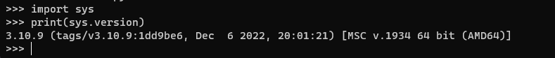

1. What is the release date?



1. What is the full command to get help?

Help()

1. Show the list of all keywords.

-Import keyword

-keyword.kwlist

5- Show the list of all Module

help('modules')

